**Bug Report**

**Website:**

https://demo.vuestorefront.io

**Bug 1:**

In this bug when you click help and FAQ link the help and FAQ link does not open.

|  |  |  |  |
| --- | --- | --- | --- |
| **Severity** | **Issue Type** | **Frequency** | **Environment** |
| Low | No Response | Every time | All Environment |

**Action Performed:**

1. Open https://demo.vuestorefront.io/
2. Click on the help and FAQ section in the navigation bar.

**Expected Result:**

Help and FAQ section should open.

**Actual Result:**

There is no response on the webpage.

**Attachment:**

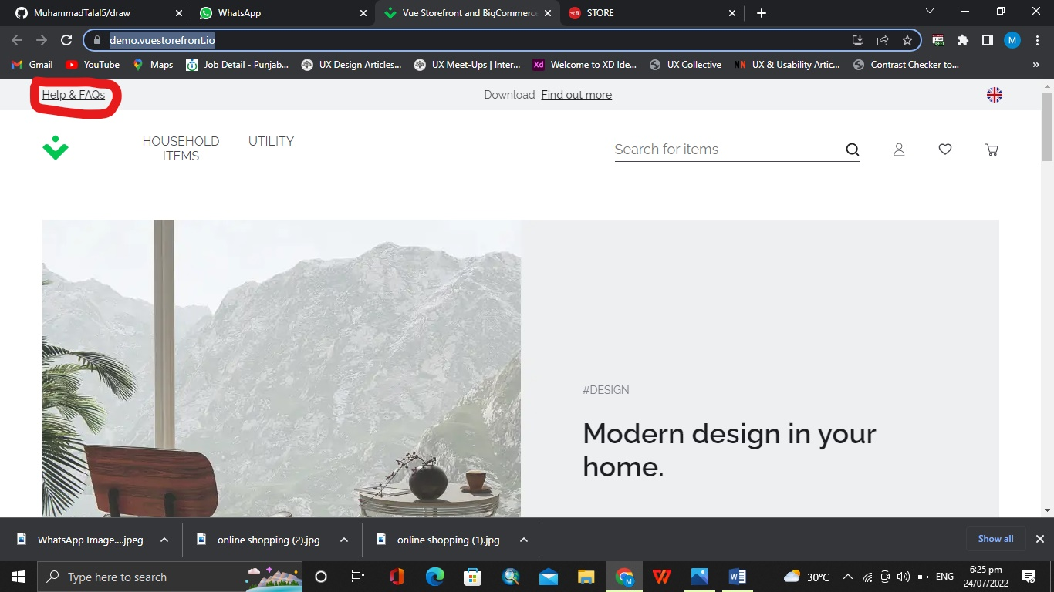

**Bug 2:**

In this bug when you click on find out more link, link does not open.

|  |  |  |  |
| --- | --- | --- | --- |
| **Severity** | **Issue Type** | **Frequency** | **Environment** |
| Low | No Response | Every time | All Environment |

**Action Performed:**

1. Open https://demo.vuestorefront.io/
2. Click on the download find out more link section in the navigation bar.

**Expected Result:**

Download (Find out more) section should open.

**Actual Result:**

There is no response on the webpage.

**Attachment:**

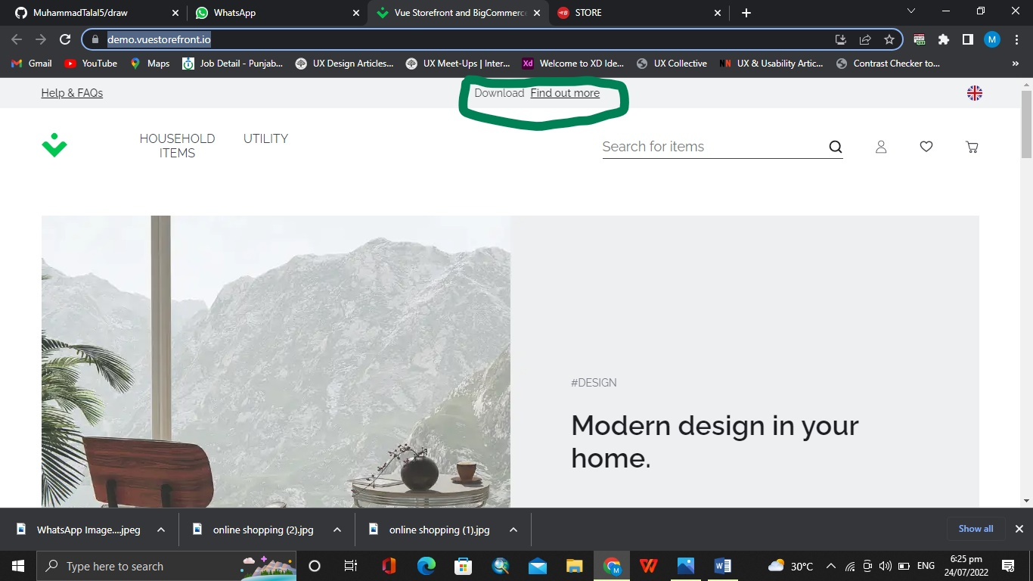

**Bug 3:**

In this bug when you click on who are we link the link does not open.

|  |  |  |  |
| --- | --- | --- | --- |
| **Severity** | **Issue Type** | **Frequency** | **Environment** |
| Low | No Response | Every time | All Environment |

**Action Performed:**

1. Open https://demo.vuestorefront.io/
2. Click on the download find out more link section in the navigation bar.

**Expected Result:**

Download (Find out more) section should open.

**Actual Result:**

There is no response on the webpage.